**Table S1:** Definition of quantitative phenotypic traits

|  |  |  |
| --- | --- | --- |
| **Phenotypic trait** | **Definition** | **Units** |
| **VB Distance** | Distance between Central VB and its closest VB | [$μ$ m] |
| **VB density** | Number of VB per cross section area | [mm2]-1 |
| **1° VB Density** | Number of 1° VB per cross section area | [mm2]-1 |
| **2° VB Density** | Number of 2° VB per cross section area | [mm2]-1 |
| **1° VB / Total VB** | Proportion of 1°VB | - |
| **VB Diameter** | Mean VB Diameter | [$μ$ m] |
| **VB Area %** | Proportion of cross section area occupied by VB | % |
| **IBS Cell size** | Mean cell area in the cross section | [m2] |
| **IBS Area %** | Proportion of cross section area occupied by IBS | % |
| **OBS Cell size** | Mean cell area in the cross section | [m2] |
| **OBS Area %** | Proportion of cross section area occupied by OBS | % |
| **M Cell size** | Mean cell area in the cross section | [m2] |
| **Sb\*** | Cell interface between BS and M per cross section area | [mm]-1 |
| **Sv\*** | Cell interface between VB and BS per cross section area | [mm]-1 |
| **Leaf Size** | Total cross section area | [m2] |

**Table S2:** Quality measures for SOMs constructed with different numbers of features (filtered by expression) and grid sizes.

|  |  |  |  |
| --- | --- | --- | --- |
| **Features** | **err.quant** | **features x neuron (median size)** | **map size** |
| 13953 | 1.620 | 34.0 | 400 |
| 12573 | 1.527 | 34.0 | 361 |
| **9757** | **1.519** | **32.0** | **289** |
| 6970 | 1.596 | 35.0 | 196 |
| 4206 | 1.672 | 33.0 | 121 |

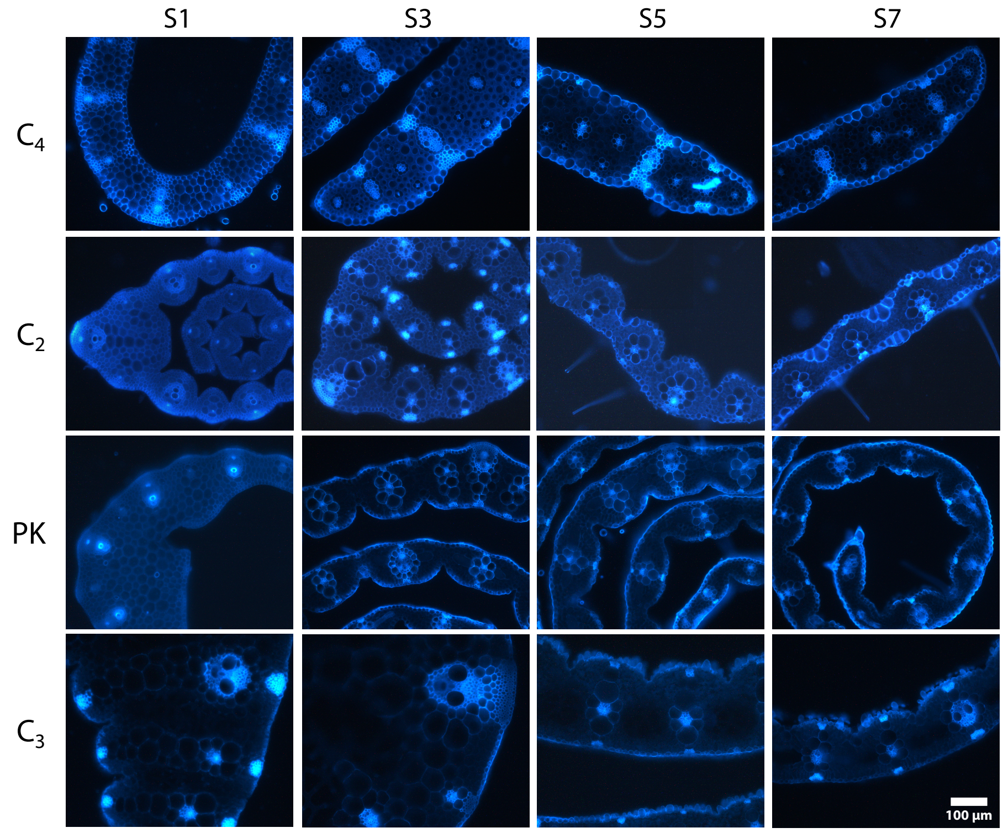

**Figure S1:** Developmental gradient in the 5th leaf of four Otachyriinae subtribe species. S1, S3, S5 and S7 cross section cuts from C4 *A. lanata*, C2 *S. hians*, PK *R. pilosa* and C3 *H. amplexicaulis*.

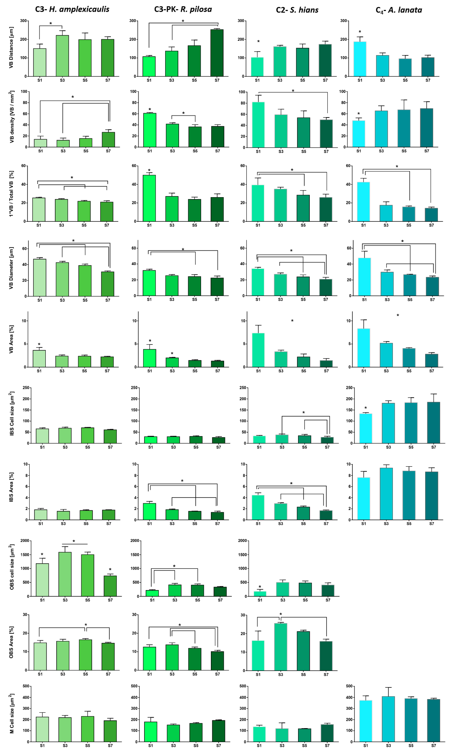

**Figure S2:** Quantitative phenotypic traits measured in the cross section cuts. Asteriks point out P-values lower than 0.05 (Friedman test and Dunn's multiple comparison test for paired samples).

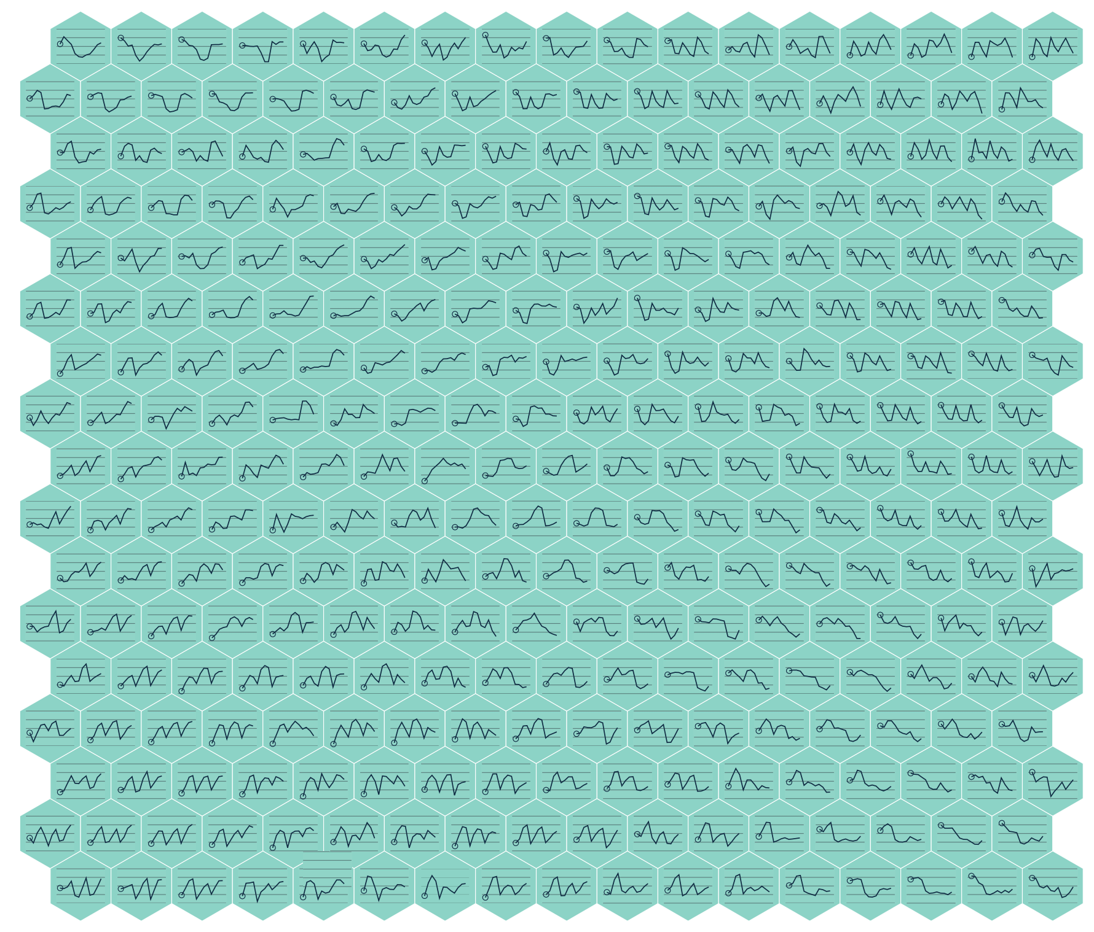

**Figure S4:** SOM line visualization plot. Neuron expression values (median) along samples. Samples order: C4-S1, C4-S3, C4-S5, C4-S7, PK-S1, PK-S3, PK-S5, PK-S7, C3-S1, C3-S3, C3-S5, C3-S7.

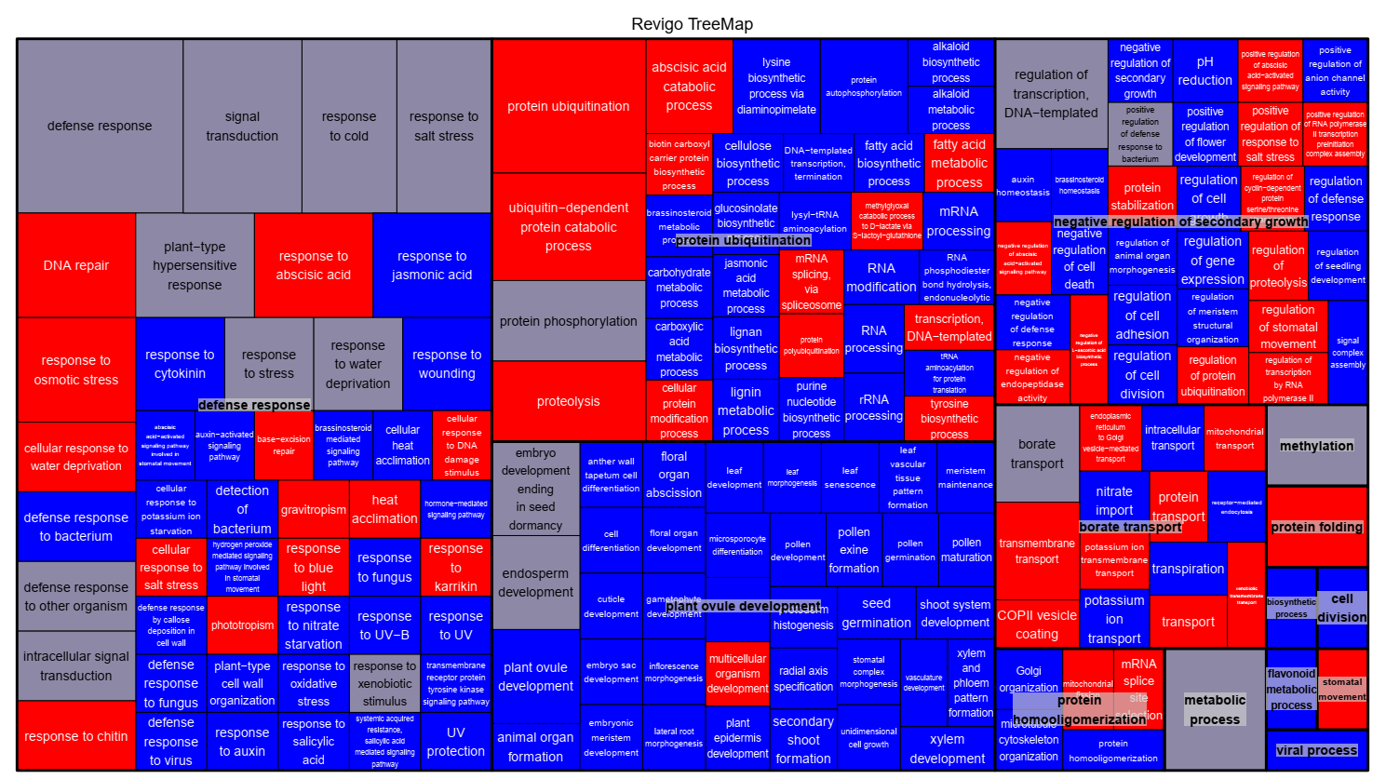

**Figure S5:** GO terms (BP) from Neurons 14 and 161 clustered by REVIGO. Rectangles showing GO terms present in neuron 14, neuron 161 or both neurons are filled with red, blue and gray respectively.

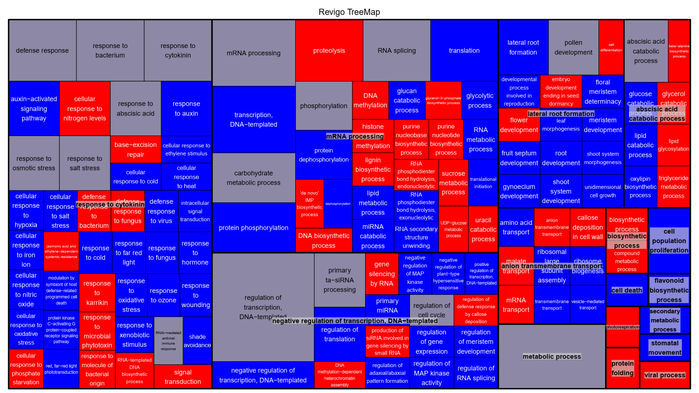

**Figure S6:**  GO terms (BP) from Neurons 15 and 160 clustered by REVIGO. Rectangles showing GO terms present in neuron 15, neuron 160 or both neurons are filled with red, blue and gray respectively.

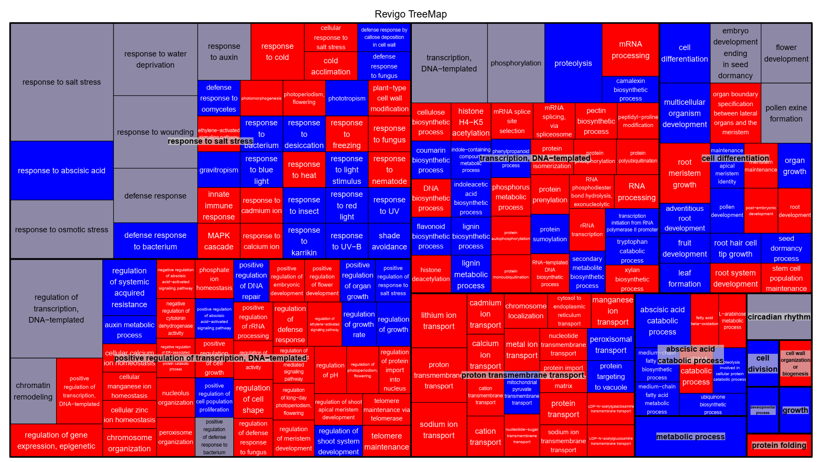

**Figure S7:** GO terms (BP) from Neurons 65 and 228 clustered by REVIGO. Rectangles showing GO terms present in neuron 225, neuron 65 or both neurons are filled with red, blue and gray respectively.

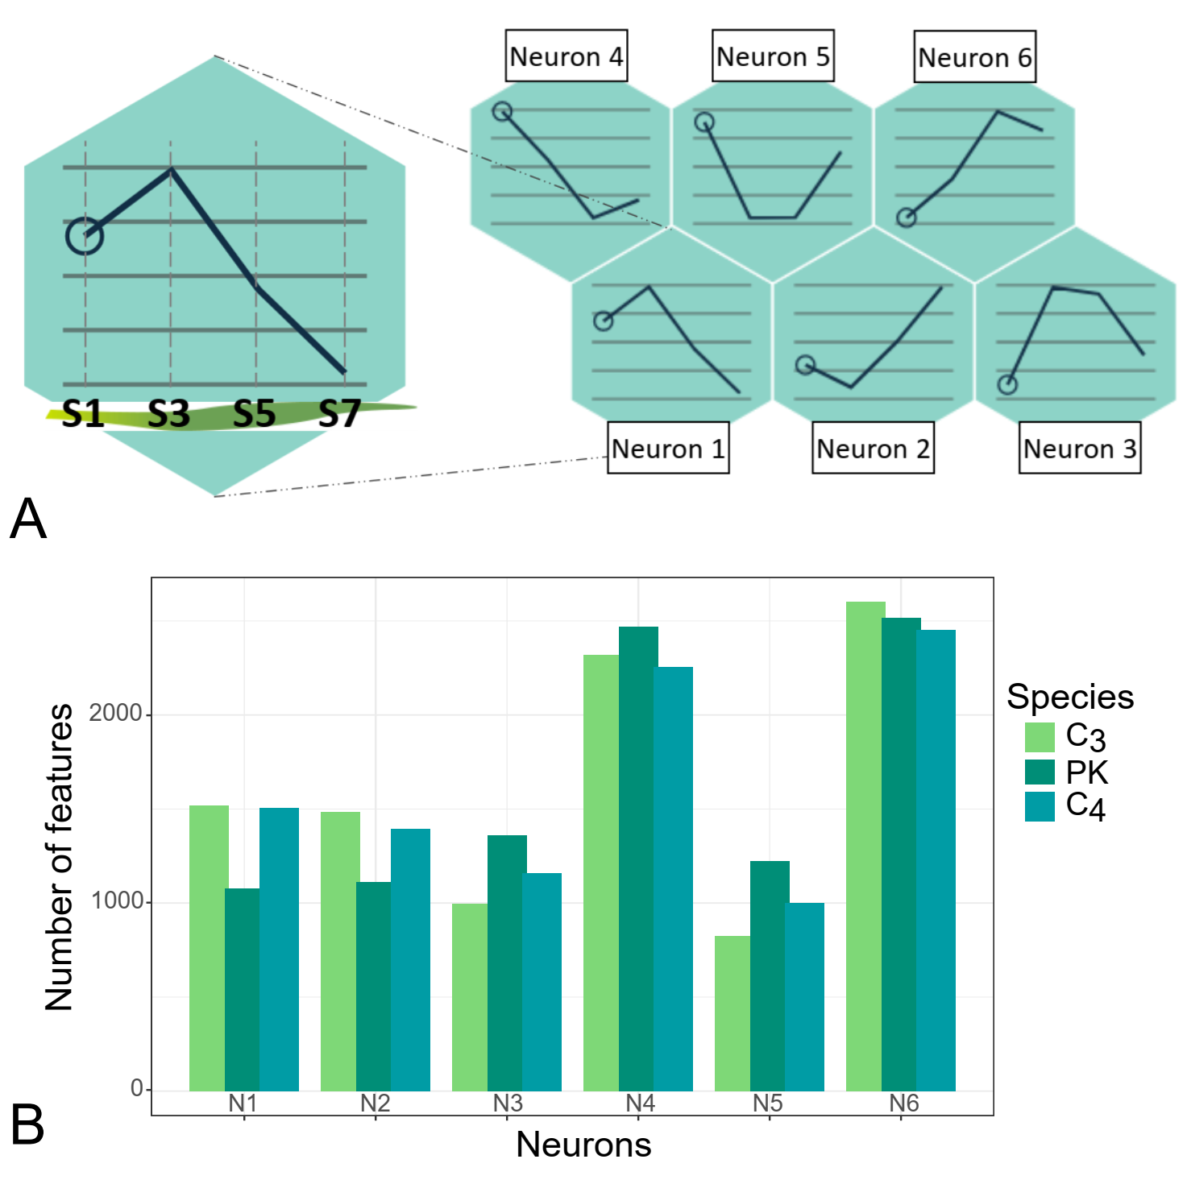

**Figure S8**: Species-specific SOM. SOM line visualization plot (A). Neuron sizes (B)

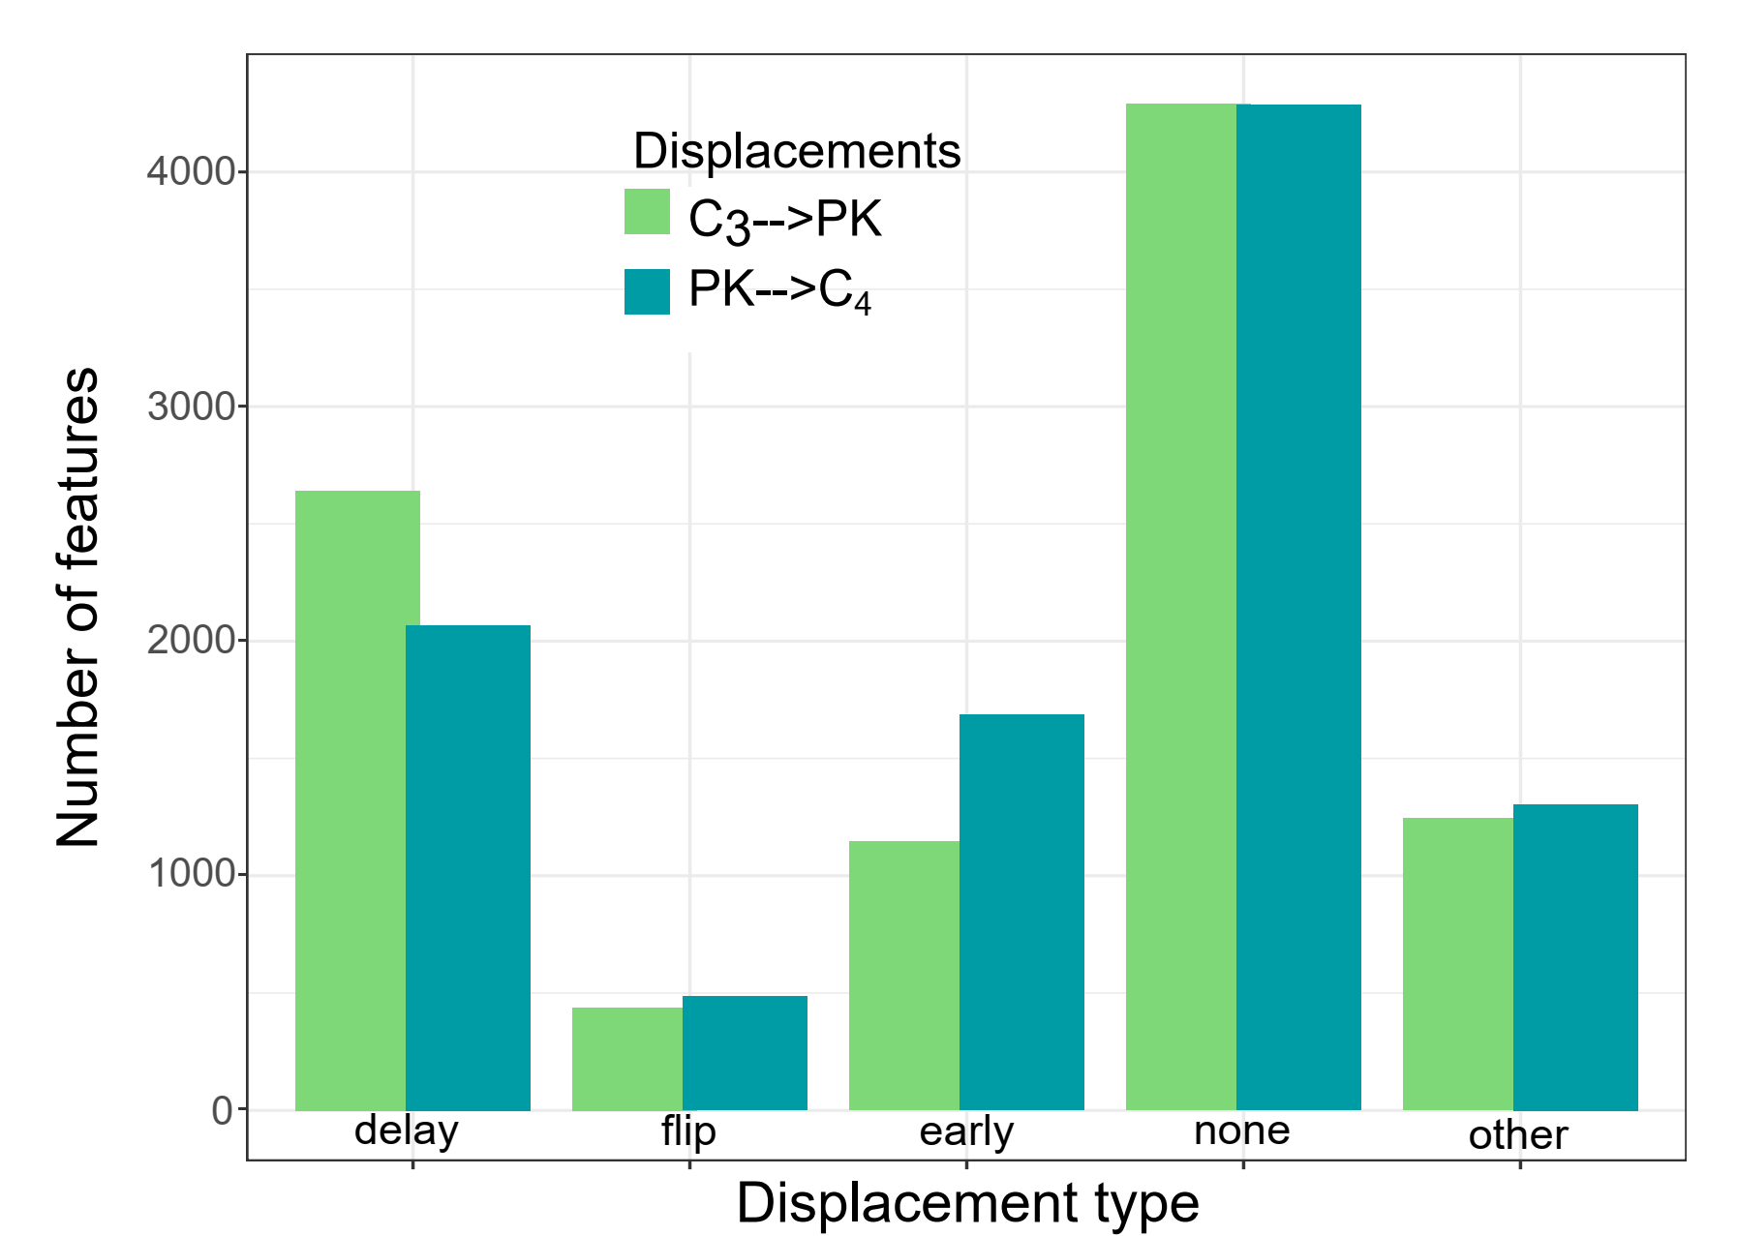

**Figure S9:** Species-specific SOM. Number of displacements between species.

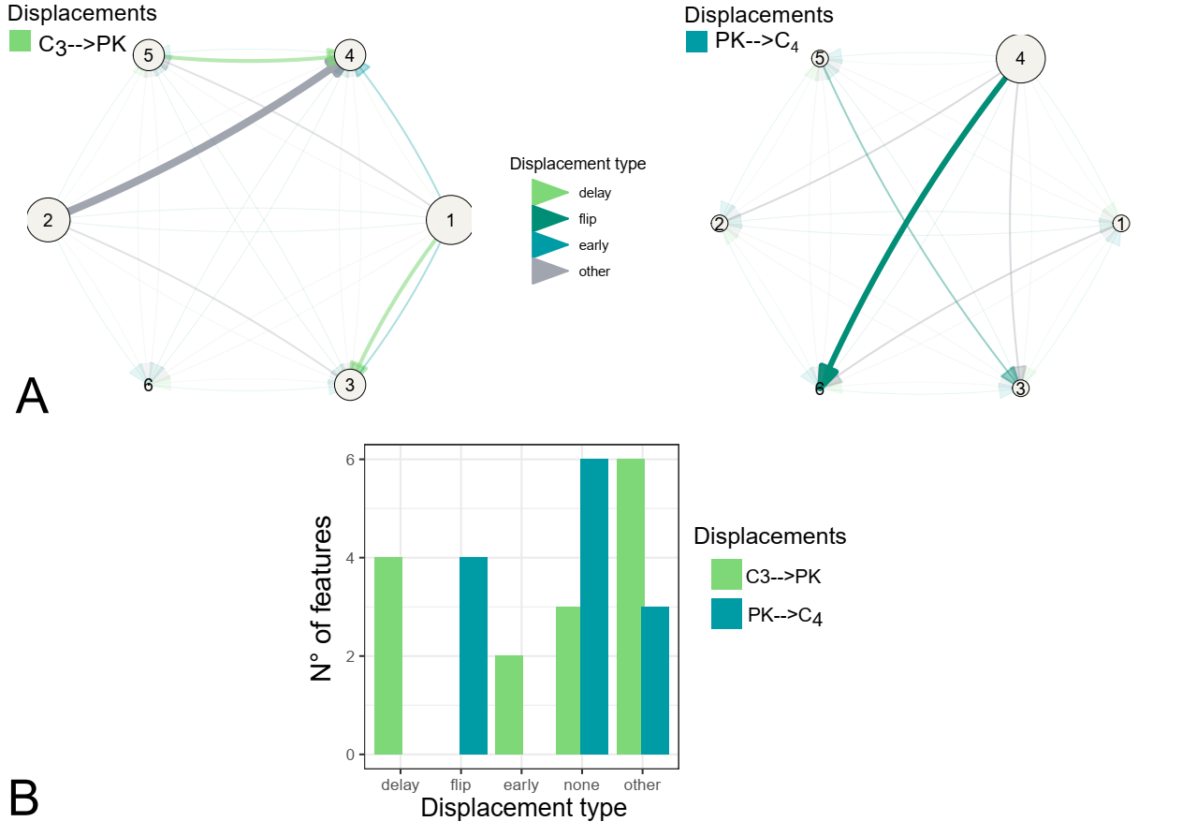

**Figure S10:** Displacement of phenotypic traits in different clusters in the SOM clustering scheme. Network representations of feature assignment into different SOM clusters using the displaced features (A). Number of displacements between species (B). Arrows represent displacement from C3 to PK and from PK to C4. Arrows and circle sizes are proportional to the number of displaced features and neuron population, respectively.